Work report 23 aug 2021

Today I have trained retina net model till 4000 epoch

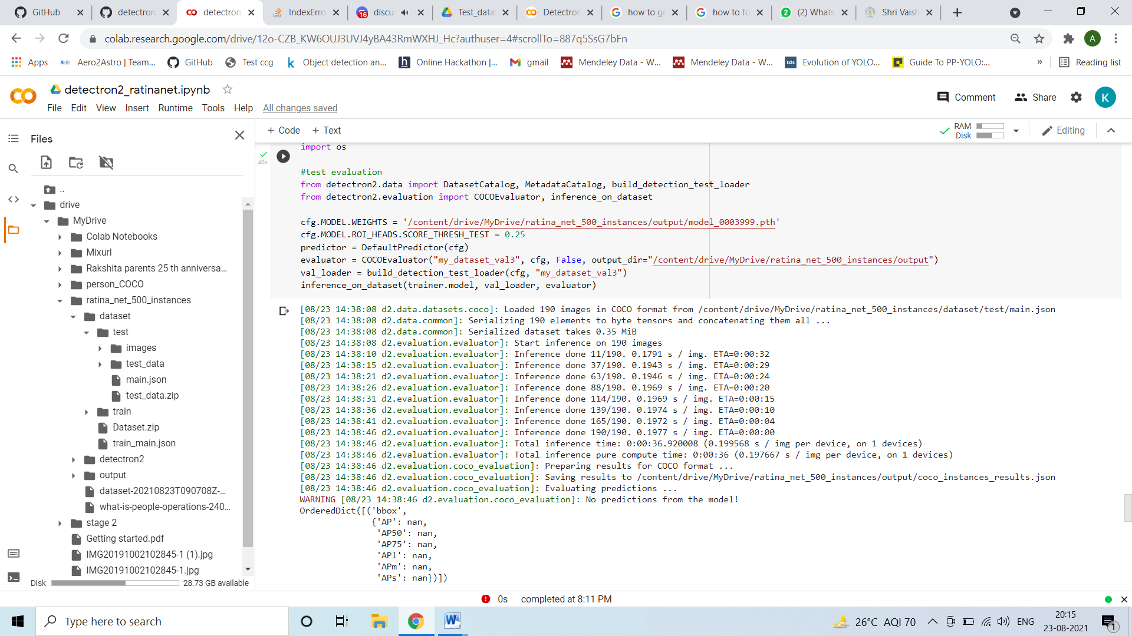

The evaluation on test data shows the model is not detecting till now.

Due to Gpu limit exceeded I was not able to check on training set